
www.galen.ma

MONÉTIQUES ET ÉQUIPEMENTS BANCAIRES

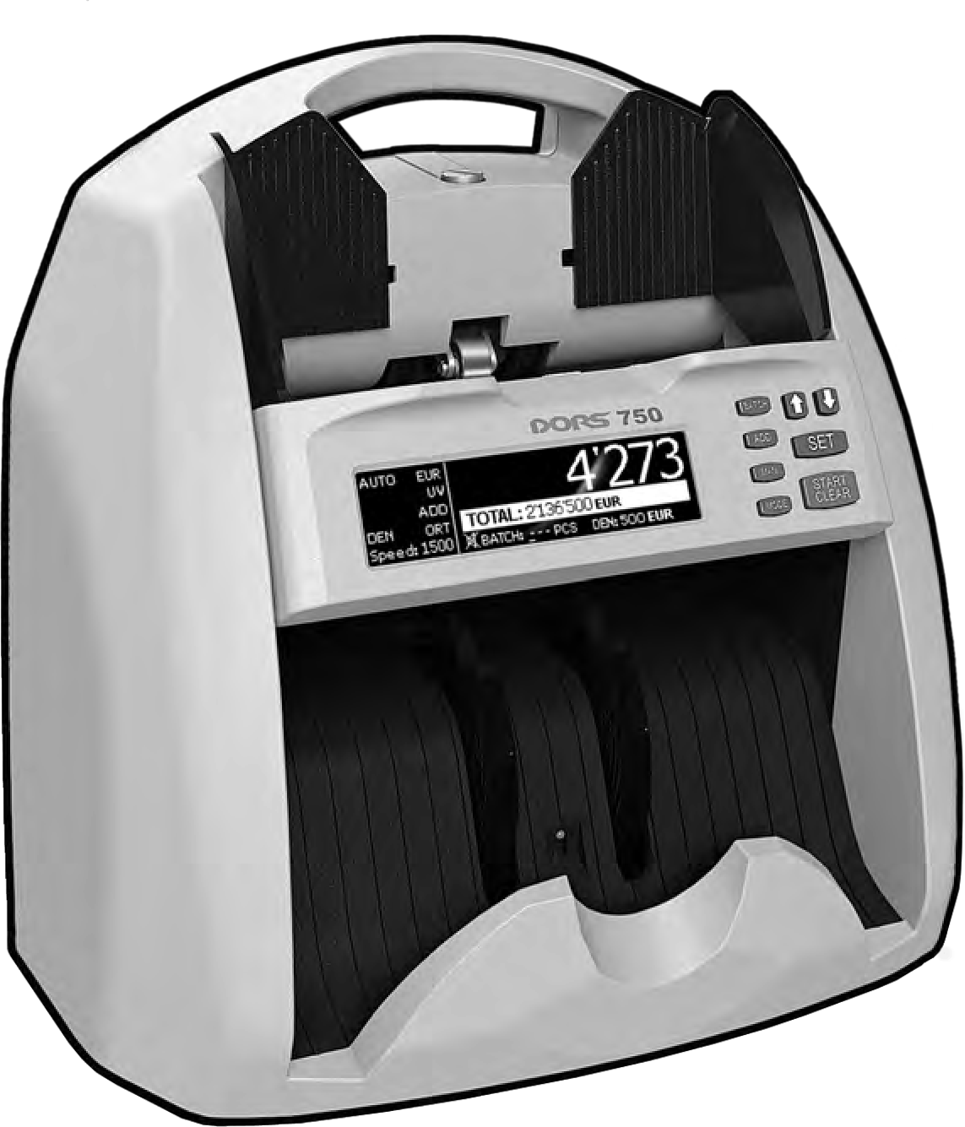

BANKNOTE COUNTER

MANUEL D'UTILISATION

CONTENTS
Introduction 4
Specifications 4
Safety Precautions. 5
Delivery Set. 6
Appearance. 6
Operating Keys. 7
Operation. 10
Menu Setup 12
Error Messages. 16
Troubleshooting 18
Counter Maintenance 18
Transportation And Storage. 18
Support And Warranty 18

DORS 750 BANKNOTE COUNTER 3

CONTENTS
SAFETY PRECAUTIONS
READ THIS MANUAL CAREFULLY BEFORE OPERATION!

Dear customer,

INTRODUCTION
To ensure long life and reliable operation of the counter, please follow these operation requirements and safety precautions:
- The counter rotating parts are potentially hazardous for the user. Therefore, we


Thank you for choosing DORS 750, the banknote counting machine that verifies an authenticity of the banknotes and indicates an amount ofgenuine notes with breakdown by denominations. The counter is intended for counting and batching of US dollars, Euros and other world and local currencies.
Authenticity verification is based on examination of visible, infrared and ultraviolet images of the counted banknotes.
DORS 750 (hereinafter «the counter») is designed by R&D DORS, Russia, and manufactured by DORS Industries (China) Ltd.

SPECIFICATIONS
Hopper capacity 500 banknotes;
Stacker capacity 200 banknotes;
Banknote counting speed (+/–15%). 600/1000/1500 banknotes per minute;
Banknote size. 117—180 mm (width),
58—90 mm (length),
0,05—0,2 mm (thickness);
Batch size 1—999;
Banknotes feed system. Friction type roller system;
Counting sensor line of sensitive optical components in
IR and red light, a built-in system of the banknote pattern recognition.
Verification in UV-T light: two-track checking of paper fluorescence level;
Display STN, graphical, 256x64 pixels;
Power supply .. 100-240VAC, 50/60 Hz;
Current consumption .................................... 0.25…0.5A;
Operating temperature range. +10°C…+35°C;
Relative humidity at + 25°C. 40% to 80%;
Atmospheric pressure 84…107 KPa (630…800 mm Hg);
Overall dimensions:
Height. 270 mm Width. 290 mm
Depth. 240 mm
Net weight 4.2 kg
Gross weight 5.4 kg
* – DORS establishes 7 years service life period for the counter provided all the service regulations are observed. Taking into account the high quality of the counter, its reliability and safety degree, the real service life of the counter may significantly exceed an official one.

4 DORS 750 BANKNOTE COUNTER
highly recommend that the users should avoid any jewelry and loose clothes, and pin their long hair when operating the counter;
- Avoid getting of any metal object or liquid into the counter;
- To connect the counter to the power network, use a mains socket with a protective earth contact (PE). The socket should be within the direct access from the teller's working place;
- Turn off and unplug the counter from the mains after the work has been completed.
- If the counter is out of use for a long time, its power switch should be in the «О» position;
- Install the device on an even horizontal surface;
- Do not use the counter at an extremely low or high temperature, and avoid high humidity; do not use the counter under the direct sun light;
- Do not touch the inside parts of the counter if it is connected to the AC mains;
- Avoid using the counter in dusty area;
- To avoid fire or short circuit, do not install the counter in the places where it may be at risk of a soot or steam impact.

DORS 750 BANKNOTE COUNTER 5

Delivery Set:

COUNTER DESCRIPTION

- The display;
- MODE key for switching the counting modes;
CONTENTS

DORS 750 BANKNOTE COUNTER 1 pc.
Power cord. 1 pc.
Quick Start guide. 1 pc.
Calibration card. 1 pc.
Package 1 set
- MAN key for switching manual start mode ON/OFF;
- ADD key for switching ADD mode ON/OFF;
- BATCH key for switching on batch mode;
- Navigation key UP ;
- Navigation key DOWN ;
- SET key to enter the menu and select menu items;

Appearance
Figure 1

Appearance
  - 1 Screw to adjust the thickness of
  - the banknotes to be counted;
3 | 2  3 | Banknote guides;  Hopper;
4 | 4 | Control panel;
 | 5 | Stacker;
 | 6 | Stacker wheels;
5
- START/CLEAR key to start counting in manual start mode and clear the results.

OPERATING KEYS
- MODE key to choose banknote counting mode.
The counter may count banknotes in three modes: COUNT, DEN and MIX. To choose a required mode, press the MODE key. The selected mode is shown in the left part of the display:
  - COUNT - The mode for piece counting. This mode allows counting of the banknotes; the quantity of the counted banknotes is shown in the display.

COUNT mode indicator The quantity of counted banknotes
6

7
- Remote display connector; 8
- USB connector;
- Power switch; 9
- Fuse; 10
- Power connector. 11

  - DEN – The mode for counting banknotes of the same denomination and their total amount. The mode is used for counting the banknotes of the same denomination with the detection in IR and red light, detection of the total amount of the counted banknotes and detection of the banknotes belonging to the given denomination (the denomination is set by the first banknote in the batch to be counted).

1 CONTROL PANEL

Control panel
Figure 2

5
6
7
4
8
3
9
2

Periodic cleaning icon

Validation level indicator

DEN mode indicator

The amount of the counted banknotes

Banknotes denomination

The quantity of the counted banknotes

Currency


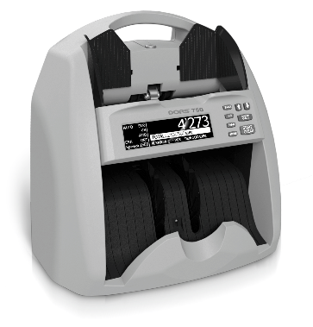
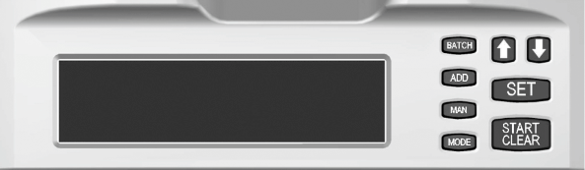
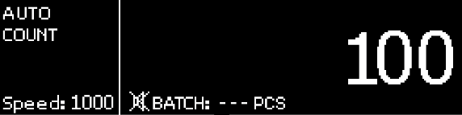
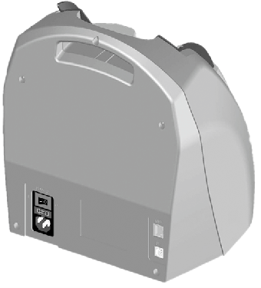
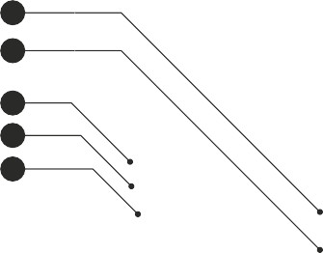
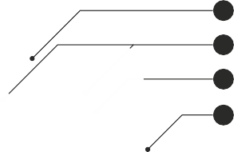



6 DORS 750 BANKNOTE COUNTER DORS 750 BANKNOTE COUNTER 7

  - MIX – The mode for counting a mixture of the banknotes with different denominations of the same currency with detection in IR and red light and with displaying of
    - the total amount and quantity of the counted banknotes;
    - the quantity of the banknotes and their amount by each denomination.
CONTENTS

3. Press MAN key to switch off the manual mode. The indicator AUTO appears in the display. The AUTO function being activated, the counter starts counting automatically as soon as a banknote gets into the hopper.
AUTO start indicator

MIX mode indicator
Total amount of the counted banknote
Total quantity of the counted banknote

Banknote denomination

The quantity of the counted banknotes by denomination

Press ▼ for detailed view
3 ADD key (summation mode)
ADD mode is used to sum the amount of the banknotes being counted by their denominations and display their total amount. Moreover, the newly-counted number will be added to the one counted before.
Press ADD key to switch on/off ADD mode. To clean the results of summing, press the START/CLEAR key and hold it while the stacker and the hopper are empty.

ADD mode indicator
The result of the accumulation the data on the banknote
counting by denominations Amount by denominations

The sum of the counted banknote by denomination

Total amount

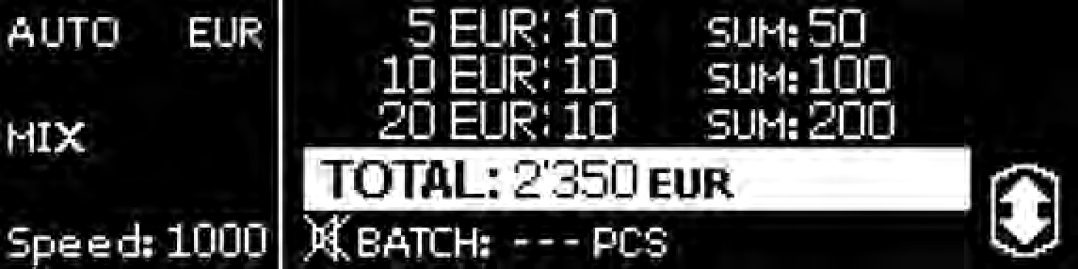
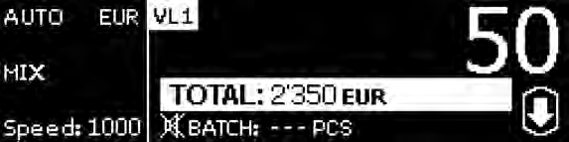
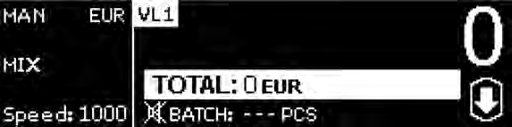
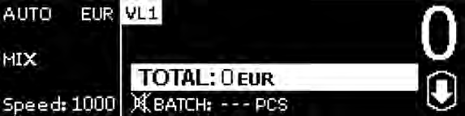
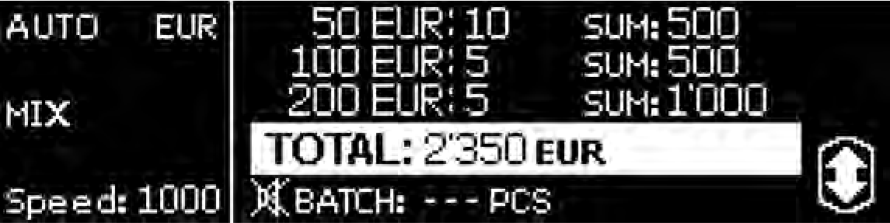
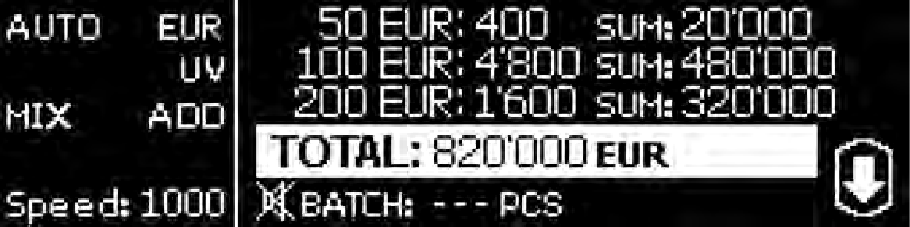
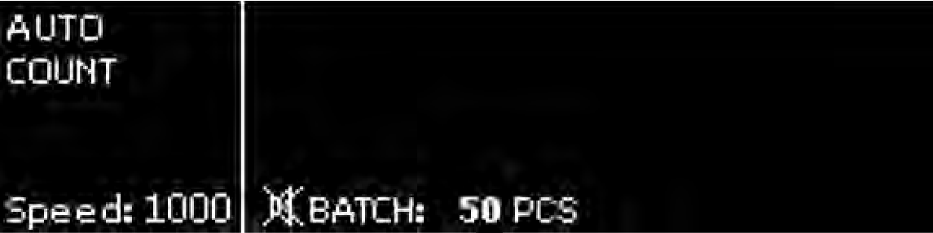

2 MAN key to choose manual/automatic counting start
- The MAN key sets the counter in a manual or an automatic start mode.
- Press the MAN key to activate the manual mode. The indicator MAN in the top left corner of the display appears at the manual start mode. To start counting, press the START/CLEAR key on the control panel.
Manual start indicator

8 DORS 750 BANKNOTE COUNTER
4 BATCH key for batch size setting
You may set the required batch size from 1 to 999 banknotes. When the batch reaches its size, the device stops, shows the total number of the counted banknotes and beeps (if the sound is switched on). If selected batch size exceeds stacker capacity, the counter stops after reaching stacker limit and resumes counting after the banknotes have been removed from the stacker. This function is available only for the COUNT and DENOMINATION modes
To set the batch size, use two methods:
- Select among the preset values - repeating pressing BATCH key will set batch size to 5-10-25-50-100 banknotes.
Batch size, selected from preset values

DORS 750 BANKNOTE COUNTER 9

- Holding the BATCH key during 3 sec. results in a manual setting of the required number. In this mode, use the navigation keys and to set the required value for the edited digit (the underlined one). To move to the next digit, use the SET key. To exit from the manual setting mode, press the BATCH key.
Number of banknotes in batch at manual setting
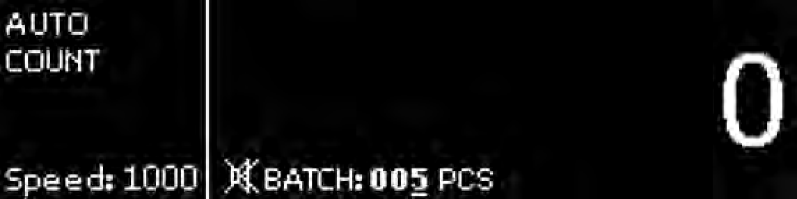

- ADD mode - OFF;
- Batch - OFF;
- Interface language - Russian;
- Counting speed -1000 banknotes per minute;
- UV detection - OFF;
- Validation level - Normal
- Currency - AUTO;
- Orientation – OFF;
- Sound - OFF
- Display backlight brightness - 2;
- Stacker capacity – 100
- Banknotes density – Normal
- External Indicator – DORS85
- UART baudrate – 9600

CONTENTS

OPERATION
- Make sure about taking into account the precautions specified in the relevant section of the manual;
- Use a power cord to connect the counter to AC mains.

- Use a power switch (9) to switch on the counter (see Fig.1). Self-testing will start after switching on: the following image (see Fig. 3) will appear in the display (1) (see Fig. 2).
Figure 3
- Adjust the gap (Fig. B) of the banknote feed system. The manufacturer presets the gap according to the local currency to be counted. However, if the counter often stops during counting, and the display shows the error messages «DOUBLE ERROR» and «CHAIN ERROR», then turn the screw (1) (see Fig. 1) slightly clockwise «–» to reduce the gap. If «NO BANKNOTE» or «LARGE ANGLE ERROR» appears in the display after the counter stops, then turn the screw (1) (see

Firmware version

Loading indicator
Self-testing screen
Fig. 1) slightly counterclockwise «+» to increase the gap.
The gap between separating rollers and feeding rollers should allow one note to pass free between the rollers stop two notes put together from passing (see Fig. 14). To check a gap, use a banknote of good quality, not worn out one. Rotate the rollers to move the cogs away from the gap. Holding the banknote as in Fig.A, put the short side of banknote between the separating rollers and feeding rollers. The banknote must pass through with a little tension. If one banknote passes freely, then decrease the gap a little. If one banknote can hardly pass between the rollers, then increase the gap. Continue gap setting until one banknote passes between the

Check the loading indicator is moving during self-test (the arrow in the bottom
part of the image) and the stacker wheels (6) (see Fig.1) and the hopper rollers (3) (see Fig. 1) are rotating. After self-test is completed, a beep sound is given and the display shows as in Fig. 4:
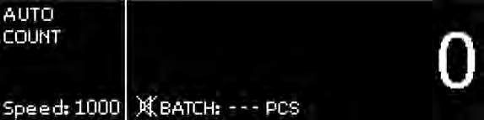
Ready for work screen
Figure 4
The gap
rollers with a little tension.
- Adjust the banknote guides according to the width of the widest banknote in the batch being counted, level the batch edges and place it carefully in the middle of the hopper avoiding its skew.

Fig. A
Fig. B

After that, the counter device is ready for counting banknotes at the following (factory) settings*.
  - Operation mode - COUNT;
  - Start mode - AUTO;
* – The factory settings may be changed according to the customer's requirements.

Fig. C
Banknote
The counter will start operation automatically. The counting stops after stacker limit is reached.
The stacker limit may be set equal to 50, 100 or 200 banknotes. After the banknotes have been removed from the stacker, the counter resumes operation automatically.

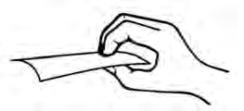
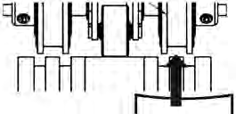
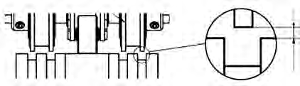
10 DORS 750 BANKNOTE COUNTER DORS 750 BANKNOTE COUNTER 11

- In case of an error, follow the recommendations of the ERROR
Figure 5

- Ultraviolet fluorescence inspection mode «UV»
CONTENTS

MESSAGES Section to eliminate the error.
Note:
Prepare the banknotes to be counted as in Fig. 5; remove the damaged, wet, greasy or dirty banknotes.
If UV is switched on, an error message will appear during the banknote counting in case a banknote with an increased UV fluorescence has been detected (for example, a banknote printed on a regular office paper), and the counting will stop.
There are 3 preset UV levels:
LEVEL 1 for the banknotes with high UV luminescence (EUR) LEVEL 2 for the banknotes with average UV luminescence (RUB) LEVEL 3 for the banknotes with low UV luminescence (USD)
Mode of UV marks inspection is switched on

UV LEVEL 1
mode is switched on

MENU SETUP
To enter the user settings menu, press and hold the SET key (see Fig.2) on the control panel during 1s. After entering the menu, the left part of the display remains unchanged, and the submenu appears in the right part.
To switch between the submenu settings, use the and keys.
To enter the submenu, press the SET key. Having selected the required setting with the and keys, press the SET key to enter the settings menu. To exit the user settings menu, hold the SET key during 1s. After you exit the menu, the display will show the selected settings.
- The interface language selection.
Select the language of display menu. Navigation keys

- VALIDATION LEVEL setting.
You may choose the level of validation (for MIX and DEN modes). For NORMAL level (indicated in the main screen as VL1) only the main authenticity features of the banknote are detected. STRICT level (indicated in the main screen as VL2) adds the detection of additional authenticity features of the banknote (if any).
NOTE: when STRICT level is selected, the control over the authenticity of banknotes increases, but the number of rejected genuine banknotes may increase.

VALIDATION LEVEL

- The banknote counting speed.
The display shows counting speed in banknotes per minute. Three values of the counting speed are available: 600, 1000, and 1500 banknotes per minute.
- CURRENCY setting.
You may choose the currency to be counted. Before the counting starts, set the currency to be counted. For AUTO (factory setting) the currency is set by the first banknote detected in the batch.


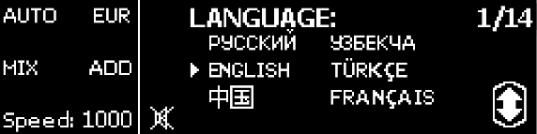
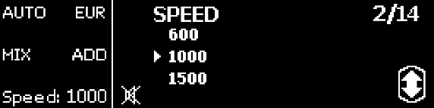

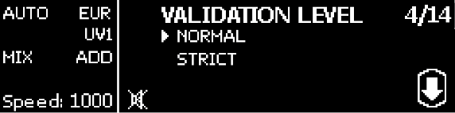
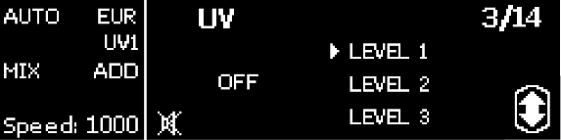
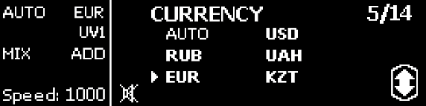

Selected currency -
EURO

Counting speed value
- DORS 750 BANKNOTE COUNTER DORS 750 BANKNOTE COUNTER 13

- ORIENTATION setting.
When counting in this mode, orientation of the banknotes of the batch to be counted is checked to match the first detected banknote. In case of mismatch, the counting stops and
an error message appears (this

- External Indicator setting.
Choose the required external device for connection.
CONTENTS

setting is available only in the DEN mode).
- SOUND setting.
ORIENTATION
mode indicator

«None» for no device connected; «DORS85/90» for DORS external display;
«POS Printer» or «CCTV» for corresponding equipment.

The mode being switched on, the executed operations are followed by beep signal.
- UART baudrate setting.
Choose the required baud rate for external printer or CCTV connection to match their
specifications.

SOUND on
indicator

- BRIGHTNESS
setting.
Choose one of three levels of brightness for display backlight to adapt to
environmental lighting.
- STACKER CAPACITY setting.
Choose desired stacker capacity in correspondence with the counted banknotes. If the
capacity changes,
«Please, reboot» message appears in the screen.
The counter will resume its
operation after restart.
- Banknotes Density setting.
Choose counted banknotes' optical density:
«Low» for more transparent banknotes;
«Normal» for regular density banknotes;
«High» for opaque banknotes.

- Display large total ON/OFF.

- INFORMATION.
The technical information for the service center staff.

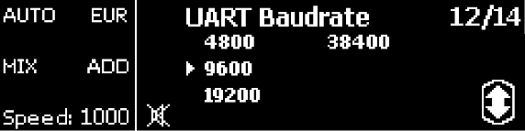
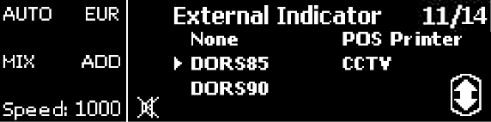
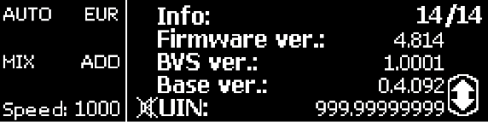
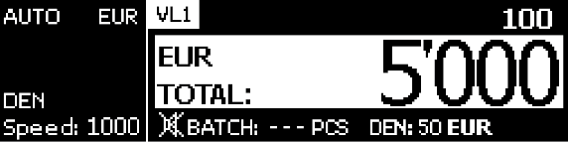
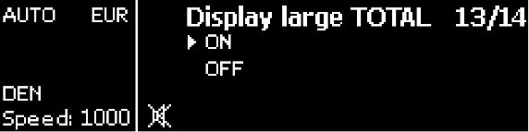
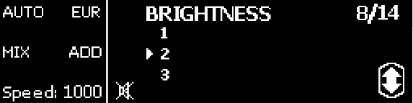
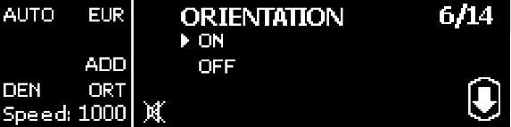
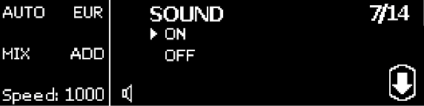
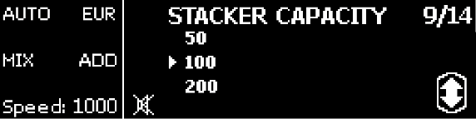
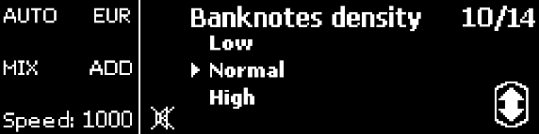
14 DORS 750 BANKNOTE COUNTER DORS 750 BANKNOTE COUNTER 15

ERROR MESSAGES
In case of an error, the counter automatically stops, gives a beep signal (at the sound switched on) and an error message appears in the display. Refer to tables 1 and 1a «Error messages» to determine the error reason and its elimination method. Sometimes, in case of a problem, the error code is not displayed or it differs from the codes in the tables 1 and 1a. Then refer to table 2 «Troubleshooting» to resolve the problem.
Table 1. Error messages that appear upon switching the counter on

Table 1a. Error messages that appear during counting
ERROR MESSAGES | REASON | TELLER'S ACTIONS
LENGTH ERROR | A banknote length differs by more than 10% from the length of the previous ones. | Remove the banknote different in size. Duly prepare the batch for counting.
PLEASE REBOOT | Appears after changing the stacker  limit and exit from the menu. | Restart the counter*.
HALF ERROR | A folded or a damaged banknote is detected. | Remove the banknote.
LARGE ANGLE ERROR | The banknote skew angle exceeds  ±15°. | Adjust banknote guides to the banknote width and duly prepare the batch for counting.
ORIENT ERROR | The banknote does not match the specified orientation. | Remove the last banknote (s) from the stacker and press START button to resume the operation.
VALIDATION ERROR | The banknote main authenticity features do not match with the preset ones for the specified currency. | Remove the banknote.
WIDTH ERROR | A banknote width differs by more than 10% from the width of the  previous one. | Remove the banknote.
CHAIN ERROR | A continuous chain (too long banknotes, an interval between the banknotes is too short).  It may occur during a batch formation if an excess banknote has been caught. In this case, no gap adjusment is required as it makes no impact on the problem solution. | Adjust the banknote feeder gap for operation with thinner banknotes. Remove the banknotes that got stuck together. To decrease the gap, turn screw (1) (Fig. 1) clockwise.
JAM ERROR | A banknote jammed in the path (blocking the path rotation). | Switch the counter off *. Carefully eliminate the jam manually trying to avoid any banknote damage. Switch the counter on.
ADD NOTE | An insufficient number of banknotes for the batch specified for counting. | Place more banknotes into the hopper.
FULL | The number of the counted banknotes exceeds 9999. | Press the START/CLEAR key to reset the display indications. Remove the banknotes from the stacker.
SERVICE | Maintenance is required. | Remove the banknotes and restart the counter*. If the error appears again after rebooting, then call the technician**.
DIFFERENT DENOMINATION | Detection of a banknote with a different denomination in DEN mode. | Remove the last banknote(s) from the stacker and press START button to resume the operation.
DIFFERENT CURRENCY | Detection of a banknote of some other currency in the MIX and DEN modes. | Remove the last banknote(s) from the stacker and press START button to resume the operation.
INTERNAL ERROR | Detection of an undocumented error. | Remove all the banknotes and reboot the counter; if the counter still does not operate properly, call the technician.

CONTENTS

ERROR MESSAGES | REASON | TELLER'S ACTIONS
REMOVE NOTES FROM THE HOPPER | There were banknotes in the hopper at the moment of switching on the device or it is a hopper sensor  malfunction. | Remove the banknotes from the hopper and clean hopper sensor. In case of a repeated error, call the technician.
REMOVE NOTES FROM THE STACKER | There were banknotes in the stacker at the moment of switching on the device or it is a stacker sensor  malfunction. | Remove the banknotes from the stacker or clean stacker sensor. In case of a repeated error, call the technician.
SYNCHRO ERROR | An error of the pulse sensor or of  the path motor. | Switch off the counter*, and then switch it on again. In case of a repeated error, call the technician.
CALIBRATION ERROR | An error of the sensors calibration.
COMM ERROR | Communication error.
SCANNER ERROR | Scanner sensor elements are overlapped or malfunctioning. | Turn off the counter, carefully remove the banknotes and foreign objects and turn the counter on. In case of a repeated error, call the  technician.
CLEAN SCANNER SENSORS | Scanner sensor elements are dirty. | The message is for information and will disappear in 5sec. If the message appears after each switching the device on and the dust level increases, then periodical maintenance may be required soon.
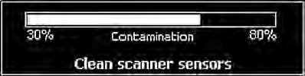

Table 1a. Error messages that appear during counting

ERROR MESSAGES | REASON | TELLER'S ACTIONS
REMOVE NOTES FROM THE STACKER | There were banknotes in the stacker when the new batch was placed in  the hopper. | Remove the banknotes from the stacker. The counter will resume operation.
NO BANKNOTE | It is impossible to load the banknotes from the hopper. | Adjust banknote guides to the banknote width and duly prepare the batch for counting. If necessary, adjust the banknote feeder gap for operation with thicker banknotes: turn screw  (1) (Fig. 1; «+» to increase the gap)
PATH CLEARING | A banknote or some foreign object blocks the sensors. | Remove the banknotes from the stacker. After 1-2 s the counter automatically rotates the path to get rid of the banknote blocking the path. If the banknote is not removed automatically, switch off the counter, remove the banknote manually and switch the counter on again. In case of a repeated error, remove the banknotes from the hopper, then remove the banknotes  from the stacker. Wait until self-cleaning is over.
DOUBLE ERROR | A doubled banknote or a very dark banknote has been detected. | Remove the banknote from the stacker. Check the banknote feeder gap for operation with thinner banknotes, and if necessary, adjust it. To adjust the gap, turn screw (1) (see Fig.1)  clockwise.
UV ERROR | A banknote with an increased fluorescence level detected at the  activated UV-mode. | Remove the banknote.

Note:
To cancel an error message, remove the banknotes from the stacker. The counter resumes operation automatically. To avoid a counting error in case of fault, a repeated batch counting is recommended.

* – The counter may be switched on again not sooner than 10 seconds after its switching off.
** – The counter remains operable but periodical maintenance is recommended.

16 DORS 750 BANKNOTE COUNTER DORS 750 BANKNOTE COUNTER 17

Table 2. Troubleshooting

TROUBLESHOOTING
CONTENTS

FAILURE | ELIMINATION METHOD
The counter fails to switch on. | Make sure about the counter connection to the power supply and the power cord plugging into the connector on the counter rear cover.  Make sure that the power switch is in position «I».  If these terms are observed but the counter fails to switch on, call the technician.
The display shows a message not described in the «Error messages» table. | Switch the counter off. Call the technician.

COUNTER MAINTENANCE
A preventive maintenance requiring partial disassembling of the counter by a service technician is recommended every 90 days. In case of an intensive use (more than one shift a day), the maintenance should be more frequent.
On a daily basis:
- Switch off the banknote counter if you do not use it.
- Wipe the counter external parts with a dry clean lint-free tissue.

TRANSPORTATION AND STORAGE
Transport the counter in the manufacturer's package by car, by railway (in a boxcar), or by air - in the pressurized modules at a temperature of -20°C to +50°C, air relative humidity up to 98% at +25°C and the air pressure 84 to 107 kPa (630 to 800mm Hg).
Store the counter (in the manufacturer's package) in a heated and ventilated storage room, at the temperature of +5°C to +40°C and a relative humidity not exceeding 80% at +25°C.

SUPPORT AND WARRANTY
DORS products supplied to your country are manufactured taking into account operation conditions in the country.
To make sure about it, please, check the official conformity marks on the product and its package.
In case of counter malfunctioning please apply to your supplier.
To avoid any misunderstanding, we earnestly ask you to study properly the terms and conditions of the counter operation, its transportation and storage and the warranty terms and conditions provided by your supplier. DORS reserves the right not to provide the product warranty maintenance if warranty terms are not observed.

18 DORS 750 BANKNOTE COUNTER

CONTENTS

www.galen.ma

© DORS LLC 2024
Production date:

User Manual Version 5.0

